**Report**

|  |  |
| --- | --- |
| Date | 27 July 2024 |
| Team ID | - |
| Project Name | Global Food Production Trends and analysis |
| Maximum Marks | 5 Marks |

## Power BI Report Summary

This Power BI project examines global food production trends from 1961 to 2023 across key crops and regions. It includes interactive and responsive visualizations aimed at agricultural strategists and policy stakeholders.  
  
Power BI was used to:

* Connect and model production data across decades
* Visualize crop and fruit production patterns globally
* Highlight regional and commodity-level insights
* Build user-friendly visuals with interactivity and drill-through capabilities

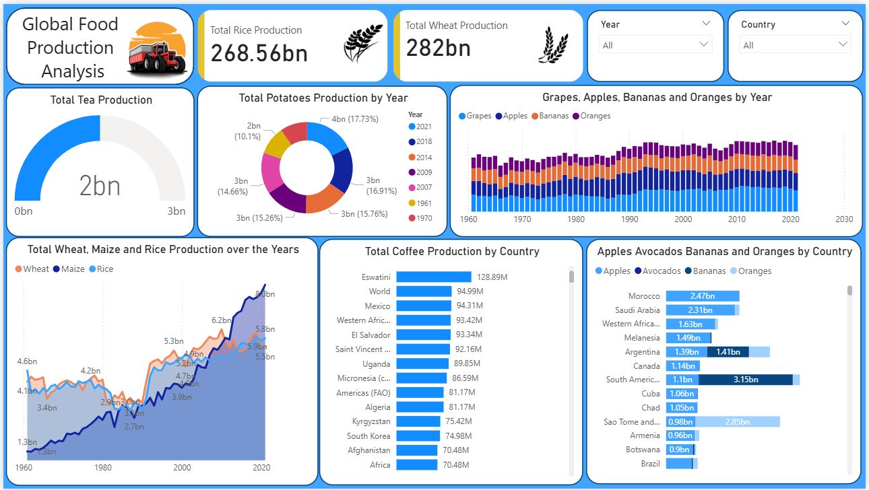

## Key Observations from the Dashboard

**Trends Over Time:**

* Wheat, maize, and rice have shown strong growth since the 1980s.
* Wheat leads with a production of 282 billion tonnes, showing consistent upward trends across decades.
* Rice production reached 269 billion tonnes, with notable growth in Asia and Africa.

**Performance Comparisons:**

* Grapes topped total fruit production at 43 billion tonnes, followed by apples (39B), bananas (32B), and oranges (26B).
* Regionally, Europe and Asia contributed the most to fruit production, especially in apples and bananas.
* Africa leads in green coffee production, surpassing the Americas and Asia.

**Entity and Regional Focus:**

* A bar chart comparison reveals high output from countries like China, India, USA, and Brazil.
* The stacked bar chart for apples, avocados, bananas, and oranges shows diversified global distribution.

**Goal Achievement (KPI Overview):**

* Production KPIs such as total wheat, rice, tea, and maize are clearly presented using card visuals and gauge charts.
* The donut chart for maize production visually captures year-on-year contribution, making it easier to assess peak performance years.

## Example Insights

• **Wheat Production**: With 282 billion tonnes produced globally, wheat emerges as the most significant staple crop in the dataset.

• **Tea Production**: A relatively small but steady output of 2 billion tonnes, with high representation in Asia.

• **Maize Trends**: Production has been consistently growing since the late 1980s, particularly in the Americas.

• **Green Coffee**: Africa dominates in green coffee production, indicating a strong market position for the continent.

• **Interactive Report Design**: Slicers for year and region enhance the ability to filter trends and compare time spans effectively.